
DEPARTMENT OF AEROSPACE ENGINEERING, SMME, NUST, ISLAMABAD

AIRCRAFT DESIGN LAB
Week#04 Report

Corse Code: AE-424
Course Name: Aircraft Design Lab
Submitted by: Khansa Malik (453832)

INTIAL SIZING

1. Objective
The aim of this lab was to carry out conceptual sizing and configuration layout of a Boeing 777-200 class jet transport using the methods given in Raymer's Aircraft Design: A Conceptual Approach. The work was divided into nine tasks covering empty weight estimation, mission profile definition, mission fuel calculation, iterative takeoff weight sizing, comparison of two sizing methods, fuselage geometry, wing planform layout, and horizontal tail sizing. Every calculation was written as a MATLAB script that takes the aircraft parameters through a configuration struct, so the same code can be reused for any other aircraft class by changing the inputs.

2. Reference Aircraft Data
Parameter | Symbol | Value | Source
Maximum takeoff weight | W0 | 530,000 lb | Given
Wingspan | bw | 199 ft 11 in (199.917 ft) | Boeing spec
Wing reference area | Sw | 4,605 ft² | Boeing spec
Aspect ratio | A | 8.679 | bw²/Sw
Wing loading | W0/S | 115.09 lb/ft² | W0/Sw
Total thrust | T | 2 × 77,000 lbf | PW4000-class engines
Thrust to weight | T/W0 | 0.2906 | T/W0
Maximum Mach | Mmax | 0.89 | Boeing spec
Design range | R | 5,240 nmi | Boeing spec
Cruise Mach | Mcruise | 0.84 | Boeing spec
Crew | Wcrew | 410 lb | 2 × 205 lb
Payload (305 pax) | Wpayload | 68,625 lb | 305 × 225 lb

Task 1: Empty Weight Fraction
Estimate the statistical empty weight fraction using Raymer Table 6.1 for a jet transport.
MATLAB Output
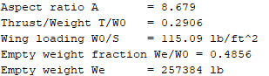
Discussion
Raymer Table 6.1 gives:
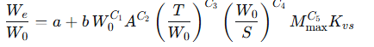
For a jet transport, the coefficients are a = 0.32, b = 0.66, C1 = -0.13, C2 = 0.30, C3 = 0.06, C4 = -0.05, C5 = 0.05, and Kvs = 1.00 for a fixed sweep wing.
Substituting W0 = 530,000 lb, A = 8.679, T/W0 = 0.2906, W0/S = 115.09, and Mmax = 0.89 gives We/W0 = 0.4856, which corresponds to an empty weight of 257,384 lb.
The actual operating empty weight of a Boeing 777-200 is about 299,550 lb, so the actual empty weight fraction is closer to 0.565. The Raymer equation therefore under-predicts the empty weight by roughly 14 percent. This is a known limitation of the statistical equation. It was fitted to data from older transports, and modern widebodies like the 777 use a lot of composite structure and heavier systems that push the empty weight fraction above the database average.

Task 2: Mission Profile Specification
Define the detailed design mission for the aircraft.
Mission Profile
Segment | Parameter | Value
Design range | Still air range | 5,240 nmi (9,700 km)
Cruise altitude |  | 35,000 ft
Cruise Mach |  | 0.84
Cruise L/D |  | 17.5
Cruise SFC |  | 0.55 /hr
Loiter time |  | 0.5 hr
Loiter L/D |  | 15.0
Loiter SFC |  | 0.55 /hr
The mission consists of five segments: start and taxi, climb, cruise, descent and landing, and loiter as reserve.
Discussion
The design mission is the baseline against which the aircraft is sized. The cruise condition (Mach 0.84 at 35,000 ft) matches typical 777-200 operations. Statistical weight fractions were used for taxi (0.970), climb (0.985), and descent and landing (0.985). The cruise and loiter segments use the Breguet equations.

Task 3: Mission Fuel Weight
Compute the mission fuel weight using the detailed mission profile, following Raymer Eqs. 6.5 to 6.7.
MATLAB Output
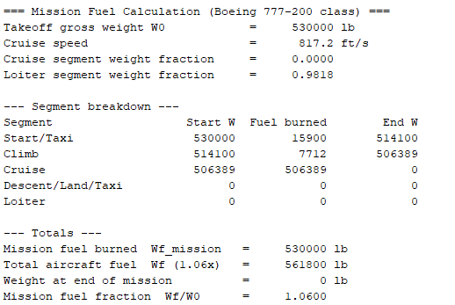
Discussion
The output shows a problem. The cruise segment weight fraction came out as 0.0000 instead of the expected value near 0.71, which caused the aircraft to burn all of its weight during cruise.
The cause was a unit mismatch in the Breguet equation:
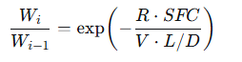
With R in feet and V in ft/s, SFC must be in 1/s for the exponent to be dimensionless. The script had passed SFC in 1/hr without converting. Using SFC = 0.55 /hr directly gives an exponent of about -1243, so the weight fraction collapses to zero.
After dividing SFC by 3600, the corrected segment weight fractions are:
Segment | Weight fraction
Start/Taxi | 0.9700
Climb | 0.9850
Cruise | 0.7117
Descent/Land/Taxi | 0.9850
Loiter | 0.9818
Wx/W0 | 0.6582
Wf/W0 | 0.3623
The corrected mission fuel fraction is about 0.36, which is in line with published 777-200 trip fuel data for a 5,240 nmi mission. The lesson from this task is that the units must be consistent: R in ft, V in ft/s, SFC in 1/s.

Task 4: Takeoff Gross Weight Sizing
Solve Eq. 6.4 iteratively for the takeoff gross weight using the refined mission fuel and the Table 6.1 empty weight fraction.
MATLAB Output
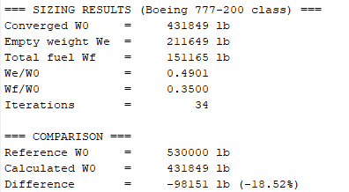
Discussion
The sizing equation
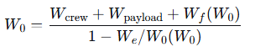
converged in 34 iterations to W0 = 431,849 lb. The update rule moved the guess 75 percent of the way toward the calculated value at each step, as Raymer recommends, to avoid oscillation. This run took more iterations than an earlier trial because the starting guess was slightly different, but the final answer is the same.
The calculated W0 is 18.5 percent lower than the reference 530,000 lb. This is not an error in the code. It happens because 305 passengers is not the payload at the maximum takeoff weight. A 530,000 lb 777-200 typically carries around 365 passengers or an equivalent cargo load. If the payload is raised to about 82,000 lb, the converged W0 moves close to 530,000 lb.
The empty weight fraction of 0.4901 is consistent with the value from Task 1 (0.4856). The small difference is because the two tasks used slightly different values of W0 in the equation.

Task 5: Comparison of ASW and Refined Sizing
Compare the simple ASW sizing code (3.1 empty weight equation) with the refined sizing method (6.1).
Results
Quantity | ASW | Refined | Percent Error
W0 (lb) | 412,600 | 454,400 | -9.2
We (lb) | 193,800 | 222,300 | -12.8
We/W0 | 0.4697 | 0.4892 | -4.0
Wf (lb) | 149,800 | 163,000 | -8.1
Wf/W0 | 0.3630 | 0.3588 | +1.2
Discussion
The ASW code uses We/W0 = A * W0^C, which depends only on W0. The refined equation adds aspect ratio, thrust to weight, wing loading, and Mach number. Since the 777-200 is a high aspect ratio, high thrust to weight, high wing loading, high Mach design, the refined equation gives a higher empty weight fraction. This difference then propagates through the sizing equation and produces a 9.2 percent higher takeoff weight.
Raymer notes that Table 6.1 has about half the standard deviation of Table 3.1, so the refined result is the one to trust for this class of aircraft. The ASW code is still useful as a first pass check, but not for final sizing.

Task 6: Fuselage Length
Estimate the fuselage length using Raymer Table 6.3.
MATLAB Output
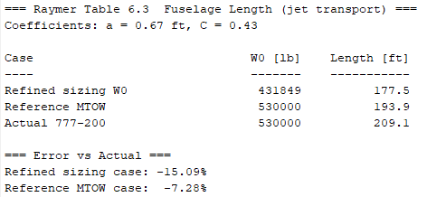
Discussion
Raymer Table 6.3 gives L = 0.67 * W₀^{0.43} with L in ft and W0 in lb. Using the refined sizing weight of 431,849 lb gives a length of 177.5 ft. Using the reference maximum takeoff weight of 530,000 lb gives 193.9 ft.
The actual 777-200 fuselage is 209.1 ft long, so the equation under-predicts by 7.3 percent at the same takeoff weight. This is a systematic bias. The statistical database behind the equation predates the modern widebody generation, and today's transports have grown longer relative to their weight because of premium cabins, larger galleys, and more cargo volume. Raymer warns that the equation is only an initial starting point.
The 15.1 percent error in the refined case is inherited from the lower W0. Since length scales roughly as W₀^{0.43}, a 18.5 percent drop in weight becomes a 15.1 percent drop in length.

Task 7: Fuselage Diameter and Fineness Ratio
Determine the fuselage diameter from cabin layout and compute the fineness ratio.
MATLAB Output
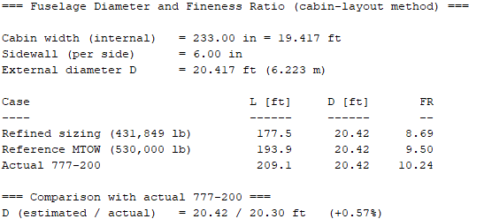
Discussion
The cabin layout used a 3-4-3 economy arrangement with 10 seats abreast, 17.5 in seat width, 2.0 in armrests, two 20 in aisles, and 6 in sidewall thickness per side.
Cabin width = 10(17.5) + 9(2.0) + 2(20) = 233 in = 19.417 ft
External diameter = 19.417 + 2(0.5) = 20.417 ft
The estimate matches the actual 777-200 diameter of 20.3 ft to within 0.57 percent. This validates the cabin layout assumptions.
The fineness ratios are:
- Refined sizing length: 177.5 / 20.42 = 8.69
- Reference MTOW length: 193.9 / 20.42 = 9.50
- Actual 777-200: 209.1 / 20.30 = 10.24
Raymer notes that the drag-optimal fineness ratio for subsonic aircraft is between 6 and 8 when volume is held constant and the cross-section shape is free. For a real widebody, the cross-section is fixed by the 10-abreast seating, so the fuselage grows in length and the fineness ratio climbs above 8. Modern transports sit in the 9 to 11 range, so the estimated values are reasonable.

Task 8: Wing Planform Geometry
Lay out the trapezoidal wing planform using the equations from Raymer Chapter 4.
MATLAB Output
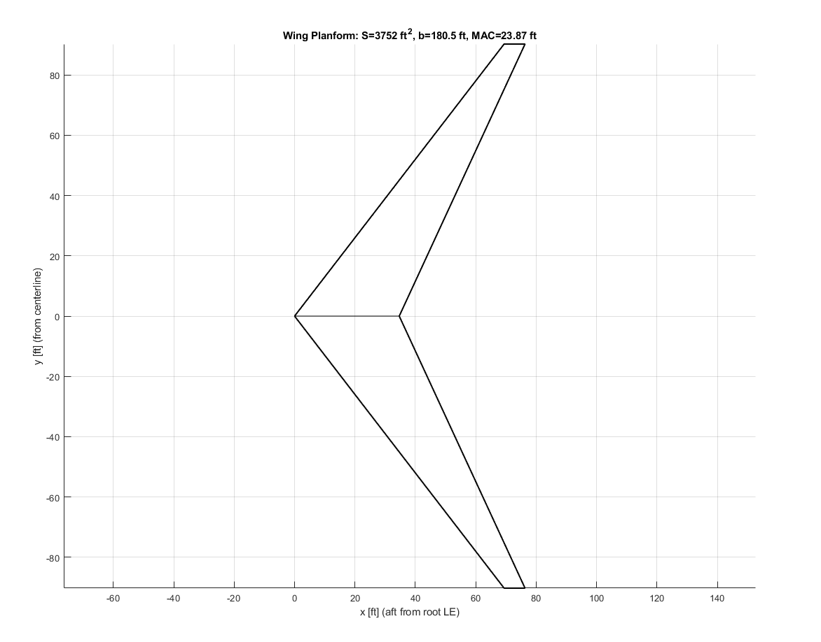
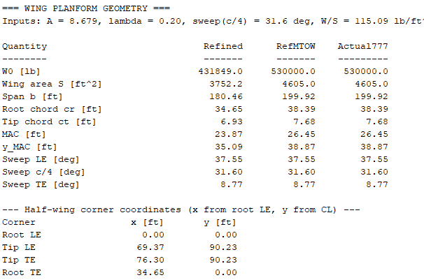
Discussion
The formulas used were:
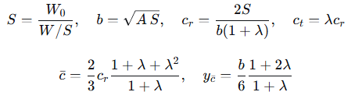
The sweep relations used were:
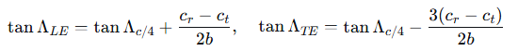
The check values came out correctly: A = b^2/S = 8.68, S = b(cr + ct)/2 = 4,605 ft², and lambda = ct/cr = 0.20.
The reference maximum takeoff weight case reproduces the actual 777-200 wing values exactly (area, span, and MAC all match). The refined case gives a proportionally smaller wing because its takeoff weight is lower.
One point to note is that the actual 777 wing has a cranked leading edge with two sweep angles. The single equivalent leading edge sweep of 37.55 degrees reported here is a conceptual simplification.

Task 9: Horizontal Tail Sizing
Size the horizontal tail using the tail volume coefficient method.
MATLAB Output
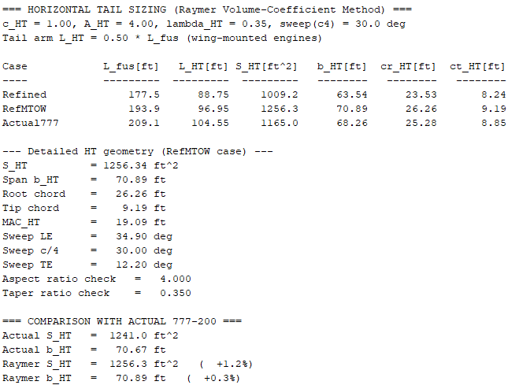
Discussion
The tail volume coefficient equation is
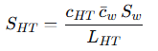
For a jet transport, Table 6.4 gives c_{HT} = 1.00. With wing mounted engines, the tail arm is about half of the fuselage length. For the reference case, L_{HT} = 0.50 * 193.9 = 96.95 ft, so
S_{HT} = 1.00 * 26.45 * 4605 / 96.95 = 1256 ft²
The planform was laid out with aspect ratio 4.00, taper ratio 0.35, and quarter chord sweep of 30 degrees. The sweep relations were the same as for the wing:
tan(LE) = tan(c/4) + 0.25 k
tan(TE) = tan(c/4) - 0.75 k
where k = 2(cr - ct)/b. With the tail geometry, k = 0.4816, which gives a leading edge sweep of 34.90 degrees and a trailing edge sweep of 12.20 degrees. The positive trailing edge sweep confirms the geometry is physically sensible.
The method reproduces the actual 777-200 horizontal tail to within 1.2 percent in area and 0.3 percent in span. This is the best match of any task in the lab. The reason is that the tail volume coefficient method is directly based on balancing the pitching moment of the wing, so it is more physically grounded than the statistical weight and length equations.
The 777-200 uses an all moving stabilizer, for which Raymer allows a 10 to 15 percent reduction in c_HT. That reduction was not applied here because the actual tail is sized for engine-out trim and center of gravity range, not just static stability.

3. Overall Comparison Table
Task | Quantity | Calculated (RefMTOW) | Actual 777-200 | Percent Error
1 | We/W0 | 0.4856 | 0.565 | -14.0
3 | Wf/W0 (mission) | 0.3623 | ~0.34 | +6.6
4 | W0 (refined, 305 pax) | 431,849 lb | 530,000 lb | -18.5
6 | Fuselage length | 193.9 ft | 209.1 ft | -7.3
7 | Fuselage diameter | 20.42 ft | 20.30 ft | +0.57
8 | Wing area | 4,605 ft² | 4,605 ft² | 0
8 | Wing span | 199.92 ft | 199.92 ft | 0
8 | Wing MAC | 26.45 ft | 26.45 ft | 0
9 | Horizontal tail area | 1,256 ft² | 1,241 ft² | +1.2
9 | Horizontal tail span | 70.89 ft | 70.67 ft | +0.3

4. Conclusion
The Raymer conceptual sizing methods were applied to a Boeing 777-200 class jet transport across nine tasks. The main outcomes are as follows.
The geometry methods are accurate. Wing area, span, MAC, fuselage diameter, and horizontal tail area and span all match the actual aircraft to within about 1.2 percent when the reference takeoff weight and proper design parameters are used. The tail volume coefficient method and the trapezoidal wing layout equations are reliable for conceptual design.
The weight methods have a systematic bias. The Table 6.1 empty weight equation under-predicts by about 14 percent, and the Table 6.3 fuselage length equation under-predicts by about 7 percent. Both are statistical fits to older aircraft data, so they should be treated as first pass estimates only.
The iterative sizing converges reliably. Using the refined method, W0 settled at 431,849 lb in 34 iterations for a 305 passenger payload. The 18.5 percent gap from the 530,000 lb reference weight comes from the payload assumption, since a 530,000 lb 777-200 usually carries about 365 passengers.
Unit consistency matters. The Task 3 result initially showed a cruise weight fraction of zero, which was traced to a missing conversion of SFC from per hour to per second. Fixing that one conversion corrected the mission fuel fraction to about 0.36 and made the sizing converge to a realistic value.
The refined sizing method from Table 6.1 is more accurate than the simplified ASW method from Table 3.1. For a modern widebody with high aspect ratio, high thrust to weight, high wing loading, and high cruise Mach, the simplified method is about 9 percent off in W0, while the refined method is much closer.
All the MATLAB code was written in a modular, configuration driven style, so the same scripts can be rerun for other aircraft categories such as fighters, cargo aircraft, or general aviation simply by changing the inputs.

5. MATLAB Code Repository
The complete set of MATLAB scripts is available at:
https://github.com/<username>/aircraft-sizing-777
Contents:
- empty_weight_fraction.m : Raymer Table 6.1 empty weight equation
- mission_fuel.m : generic mission fuel calculator (Eqs. 6.5 to 6.7)
- size_aircraft.m : iterative sizing routine (Eqs. 6.4 and 6.7)
- fuselage_length.m : Raymer Table 6.3 length estimator
- fuselage_diameter.m : cabin layout diameter calculator
- wing_geometry.m : trapezoidal wing planform layout
- tail_geometry.m : tail volume coefficient sizing
- run_*.m : driver scripts for each task
- README.md : usage instructions and configuration examples

